**SELF JOIN**

* Join a table to it as if the table were two tables; temporarily renaming at least one table in the SQL statement.
* When a table references data in itself.

Syntax

SELECT a.column_name, b.column_name...

FROM table1 a, table1 b

WHERE a.common_field = b.common_field;

Where clause could be any given expression based on your requirement.

* Must use aliases otherwise the column names would be ambiguous.
* Not knowing which of the two copies of the table’s columns is being referenced without using an alias for each copy of the table.

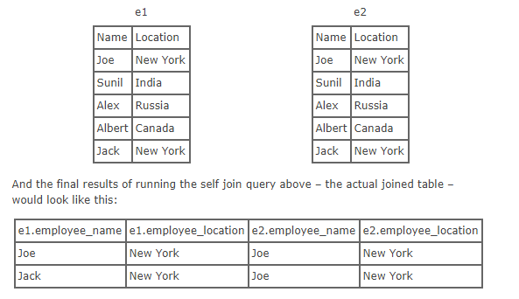

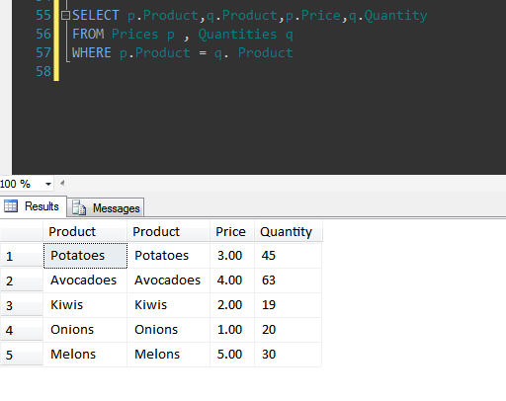

**To Create Adventure Works database**

CREATE DATABASE [AdventureWorks] ON

( FILENAME = N'D:\Neeraja\STEP\STEP2017\AdventureWorks2012_Data.mdf' ),

( FILENAME = N'D:\Neeraja\STEP\STEP2017\AdventureWorks2012_log.ldf' )

FOR ATTACH